Họ và tên : Huỳnh Khánh Phong

MSSV ; 1150070034

Lab 3

**Viết Activity.xml**

<?xml version="1.0" encoding="utf-8"?>  
<LinearLayout xmlns:android="http://schemas.android.com/apk/res/android"  
 android:layout_width="match_parent"  
 android:layout_height="match_parent"  
 android:orientation="vertical">  
  
 <ListView  
 android:id="@+id/lv_user"  
 android:layout_width="match_parent"  
 android:layout_height="wrap_content"/>  
</LinearLayout>

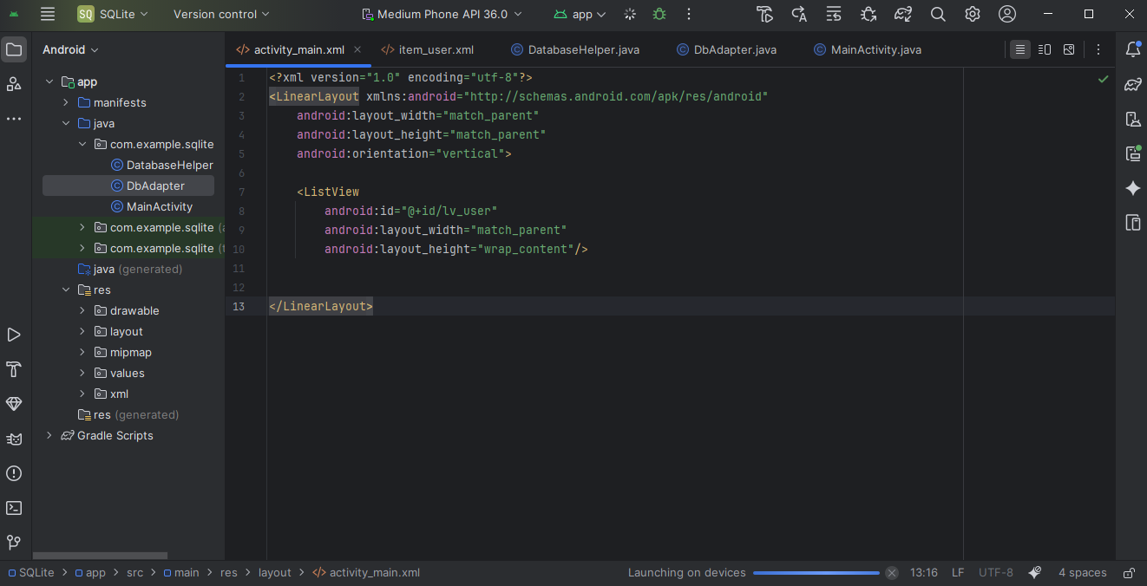

**Viết Item_user.xml**

<?xml version="1.0" encoding="utf-8"?>  
<TextView xmlns:android="http://schemas.android.com/apk/res/android"  
 android:id="@+id/tv_user"  
 android:layout_width="wrap_content"  
 android:layout_height="wrap_content"  
 android:padding="8dp"/>

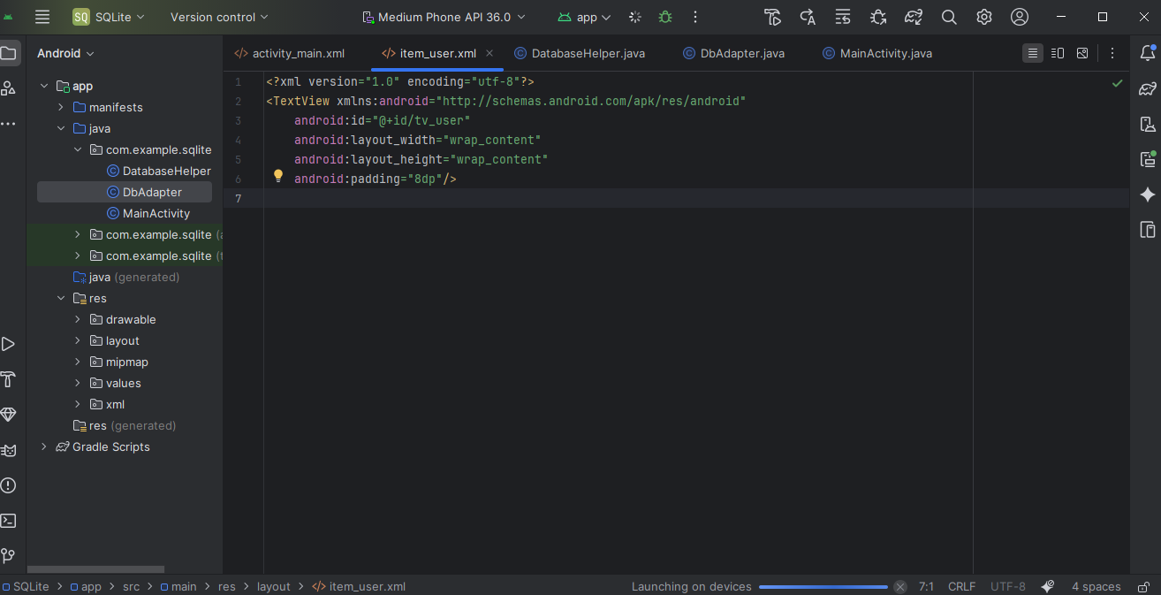

**Viết DatabaseHelp.java**

package com.example.sqlite;  
  
import android.content.Context;  
import android.database.sqlite.SQLiteDatabase;  
import android.database.sqlite.SQLiteOpenHelper;  
 public class DatabaseHelper extends SQLiteOpenHelper {  
 private static final String *DATABASE_CREATE* =  
 "create table users (_id integer primary key autoincrement, name text not null);";  
  
 public DatabaseHelper(Context context, String name,  
 SQLiteDatabase.CursorFactory factory, int version) {  
 super(context, name, factory, version);  
 }  
  
 @Override  
 public void onCreate(SQLiteDatabase db) {  
 db.execSQL(*DATABASE_CREATE*);  
 }  
  
 @Override  
 public void onUpgrade(SQLiteDatabase db, int oldVersion, int newVersion) {  
 db.execSQL("DROP TABLE IF EXISTS users");  
 onCreate(db);  
 }  
 }

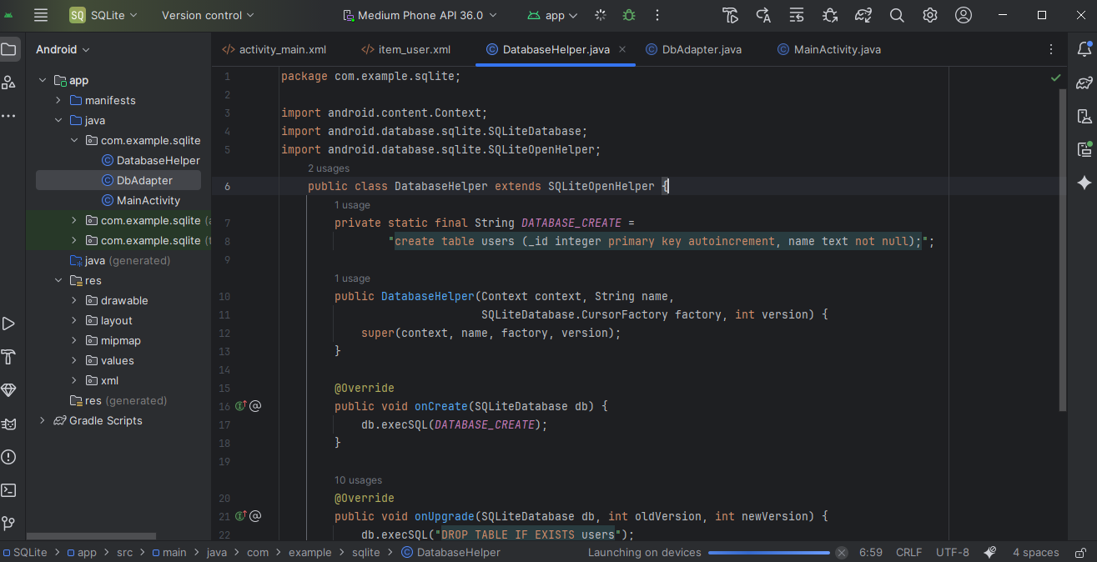

**Viết DbAdapter.java**

package com.example.sqlite;  
  
import android.content.ContentValues;  
import android.content.Context;  
import android.database.Cursor;  
import android.database.sqlite.SQLiteDatabase;  
public class DbAdapter {  
 public static final String *KEY_ID* = "_id";  
 public static final String *KEY_NAME* = "name";  
  
 private DatabaseHelper dbHelper;  
 private SQLiteDatabase database;  
 private static final String *DATABASE_NAME* = "Database_Demo";  
 private static final String *DATABASE_TABLE* = "users";  
 private static final int *DATABASE_VERSION* = 2;  
 private final Context context;  
  
 public DbAdapter(Context ctx) {  
 this.context = ctx;  
  
 }  
 public DbAdapter open() {  
 dbHelper = new DatabaseHelper(context, *DATABASE_NAME*, null, *DATABASE_VERSION*);  
 database = dbHelper.getWritableDatabase();  
 return this;  
 }  
  
 public void close() {  
 dbHelper.close();  
 }  
  
 public long createUser(String name) {  
 ContentValues values = new ContentValues();  
 values.put(*KEY_NAME*, name);  
 return database.insert(*DATABASE_TABLE*, null, values);  
 }  
  
 public Cursor getAllUsers() {  
 return database.query(*DATABASE_TABLE*, new String[]{*KEY_ID*, *KEY_NAME*},  
 null, null, null, null, null);  
 }  
 public boolean deleteAllUsers() {  
 return database.delete(*DATABASE_TABLE*, null, null) > 0;  
 }  
  
}

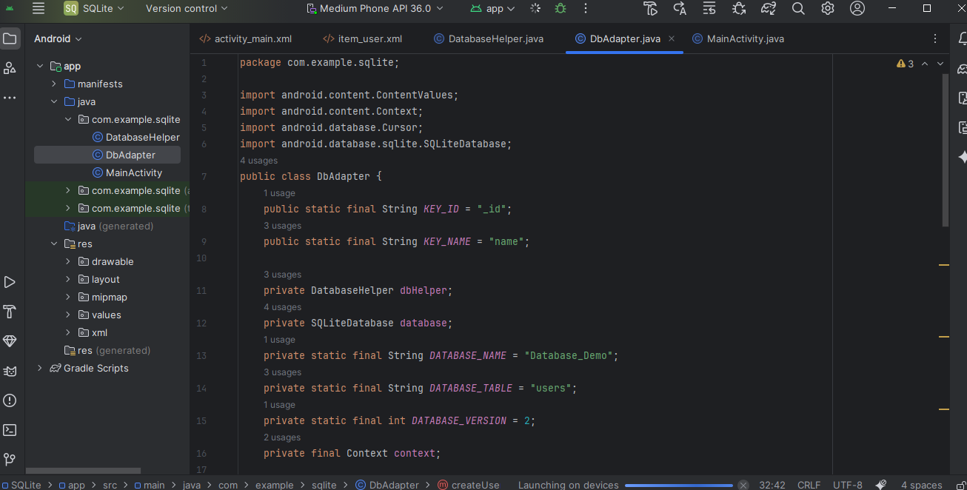

**Viết MainActivity.java**

package com.example.sqlite;  
  
import android.database.Cursor;  
import android.os.Bundle;  
import android.widget.ArrayAdapter;  
import android.widget.ListView;  
import androidx.appcompat.app.AppCompatActivity;  
import java.util.ArrayList;  
import java.util.List;  
  
public class MainActivity extends AppCompatActivity {  
 private DbAdapter dbAdapter;  
 private Cursor cursor;  
 private List<String> users;  
  
 @Override  
 protected void onCreate(Bundle savedInstanceState) {  
 super.onCreate(savedInstanceState);  
 setContentView(R.layout.*activity_main*);  
  
 dbAdapter = new DbAdapter(this);  
 dbAdapter.open();  
 // Xóa dữ liệu cũ và thêm dữ liệu mẫu  
 dbAdapter.deleteAllUsers();  
 for (int i = 0; i < 10; i++) {  
 dbAdapter.createUser("Nguyễn Văn An " + i);  
 }  
 users = getData();  
 showData();  
 }  
 private List<String> getData() {  
 List<String> userList = new ArrayList<>();  
 cursor = dbAdapter.getAllUsers();  
  
 if (cursor != null) {  
 int nameIndex = cursor.getColumnIndex(DbAdapter.*KEY_NAME*);  
 while (cursor.moveToNext()) {  
 if (nameIndex != -1) {  
 userList.add(cursor.getString(nameIndex));  
 }  
 }  
 cursor.close(); // đóng cursor để tránh rò rỉ bộ nhớ  
 }  
  
 return userList;  
 }  
  
 private void showData() {  
 ListView lvUser = findViewById(R.id.*lv_user*);  
 ArrayAdapter<String> userAdapter =  
 new ArrayAdapter<>(this, R.layout.*item_user*, users);  
 lvUser.setAdapter(userAdapter);  
 }  
  
 @Override  
 protected void onDestroy() {  
 super.onDestroy();  
 if (dbAdapter != null) {  
 dbAdapter.close(); // đóng database khi activity bị hủy  
 }  
 }  
}

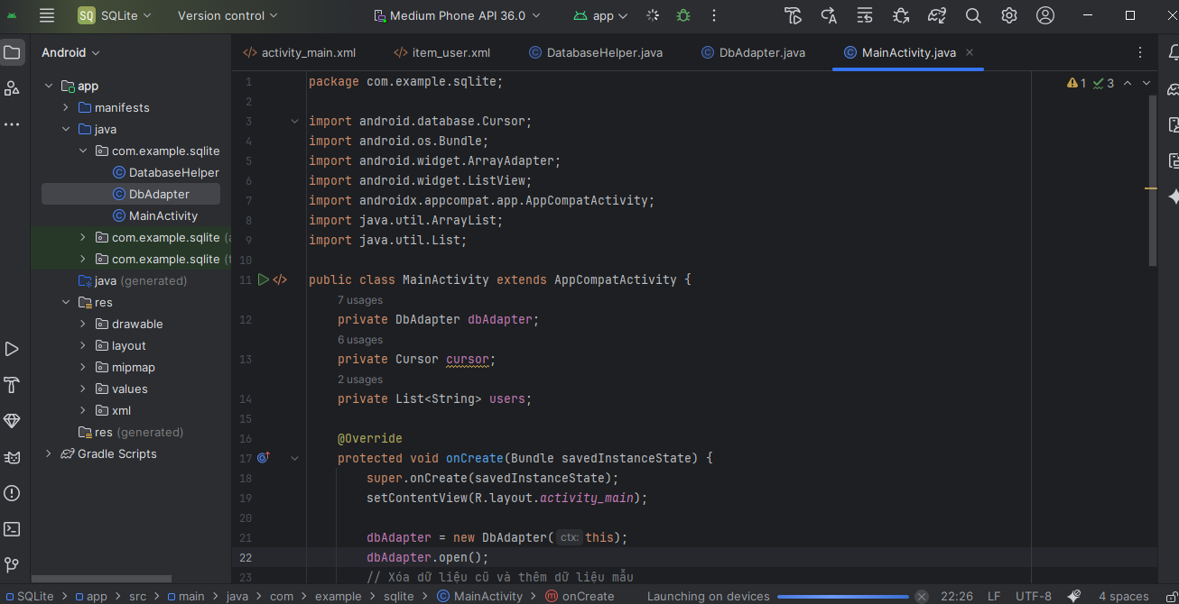

Kết quả nhận được

